Section I
Total Marks (75)

Part A
Total marks (15)
Attempt Questions 1-15
Allow about 30 minutes for this part

INSTRUCTIONS
Use the multiple choice answer sheet on page 6.
Select the alternative A, B, C or D that best answers the question. Fill in the response oval completely.

Sample 2+4= (A) 2 (B) 6 (C) 8 (D)9

A  B  C  D 

If you think you have made a mistake, put a cross through the incorrect answer and fill in the new answer.

A  B  C  D 

If you change your mind and have crossed out what you consider to be the correct answer, then indicate this by writing the word correct and drawing an arrow as follows:

correct

A  B  C  D 

_________________________________________________________________________________________
1.Which set of aqueous solutions contain [H₃O⁺] less than 10 ^{–7} mol L ^{–1} ?

- CH₃COOH, HCl, H₂SO₄
- NaCl, NH₃, H₂CO₃
- C₆H₁₂O₆, C₂H₅OH, CH₃COOH
- Na₂CO₃, Ca(OH)₂, NaHCO₃

2. Which of the following is a segment of the structure of cellulose?

(A)
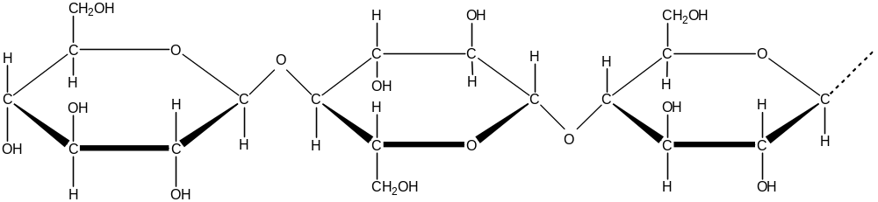

(B)
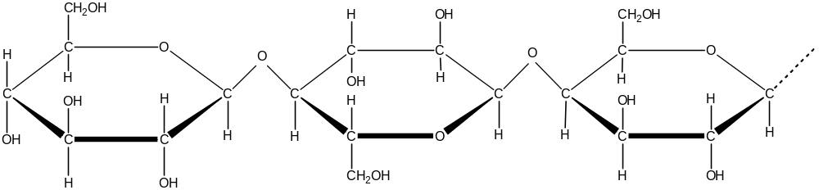

(C)
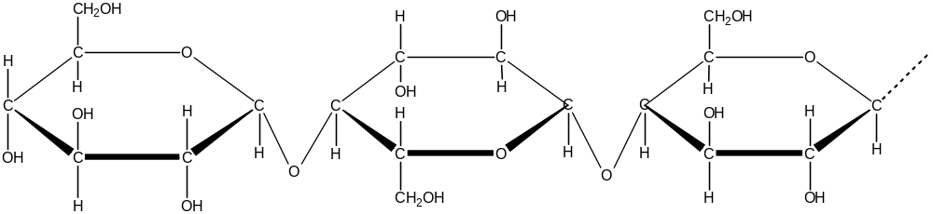

(D)
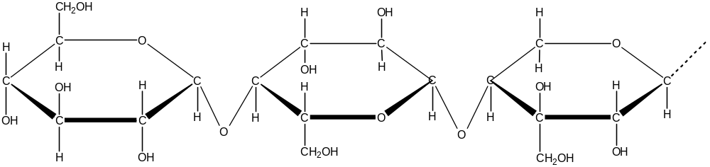

3. Which of the following galvanic cells would produce the greatest voltage?

(A) 3Mg _{(s)} + 2Al³⁺ → 2Al _{(s)} + 3Mg²⁺
(B) Sn _{(s)} + Pb²⁺ → Sn²⁺ + Pb _{(s)}
(C) Zn _{(s)} + Cu²⁺ → Zn²⁺ + Cu _{(s)}
(D) 2Ag⁺ + Cu _{(s)} → 2Ag _{(s)} + Cu²⁺

4. These half-reactions show manganese gaining electron(s) and becoming reduced. In which of the half-reactions is manganese being reduced to the greatest extent?

(A) MnO₄– + a e– → MnO₄^{2–}
(B) Mn²⁺ + b e– → Mn _{(s)}
(C) MnO₂ _{(s)} + 4H⁺ + c e– → Mn²⁺ + 2H₂O
(D) MnO₄– + 4H⁺ + d e– → MnO₂ _{(s)} + 2H₂O

5.Which of the following reactions show a transuranic element being produced?

(A)
(B) 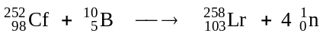
(C) 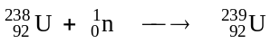
(D) 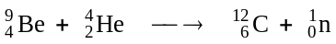

6. Repairs are done on a cracking unit at an oil refinery. An analytical chemist is asked to test the product output from the cracking unit to ensure proper operation.
Which of the following would be a valid test?

(A) test with a homologous catalyst
(B) test with limewater
(C) test with bromine water
(D) test with methyl orange

7. Which of these is the structure of styrene?
(A)
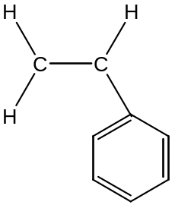 (B) 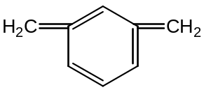
(C)
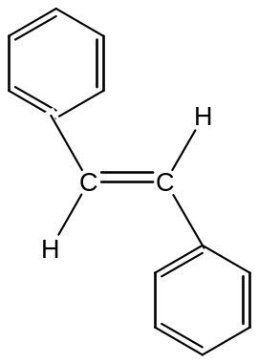 (D) 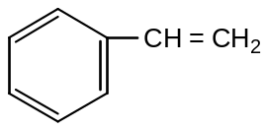

8. Which lower atmosphere pollutant and its source is incorrectly listed?

 | Pollutant | Source
(A) | ozone | photochemical smog
(B) | sulfur dioxide | metal extraction
(C) | carbon monoxide | motor cars
(D) | oxides of nitrogen | combustion (impurities in the fuel)

9. Which of the following technique or instrumentation would be most useful in qualitatively
identifying heavy metal ions in solution.

(A) Atomic Absorption Spectrometry
(B) pH meter
(C) flame test
(D) precipitation with suitable reagents

10. Which is the correct IUPAC name for citric acid?

(A) 2-hydroxypropane-1,2,3-tricarboxylic acid
(B) 2-hydroxypropane-triethanoic acid
(C) 1,1,1-tricarboxylic acid
(D) ethanoic acid

11. The 'sour' taste of fruits is often caused by the presence of alkanoic acids. What is the
functional group responsible for the properties of alkanoic acids?
C
║
O
(A)
(B)
(C)
H
C
║
O
C
║
O
OH
(D)

C
OH
│
│

12. High concentrations of SO₂ have been blamed for the increased mortality rates occurring in
times of 'smog'.
Which process would NOT release SO₂ into the atmosphere?

(A)the action of water on superphosphate fertilizers
(B) the combustion of crude oil
(C) the oxidation of sulfide ores in a smelter
(D) large eruption volcano emissions

13. Sulfuric acid can react with pyrosulfuric acid according to the equation:

H₂SO₄(l) + H₂S₂O₇ (l) H₃SO₄⁺(l) + HS₂O₇⁻(l)

Which species are acting as acids in this reaction?

(A) H₂SO₄, H₃SO₄⁺
(B) H₂S₂O₇, HS₂O₇⁻
(C) H₂SO₄ , HS₂O₇⁻
(D) H₂S₂O₇, H₃SO₄⁺

14. Which type of glassware is used in titration to deliver solution X to a known volume
of solution Y?

(A) 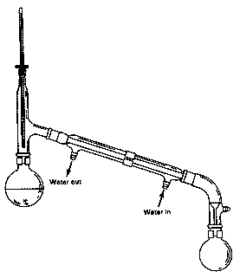 (C)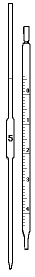
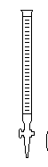
(B) 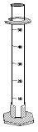 (D)

15. Which statement corresponds best with Davy's ideas about acids and bases?

(A) An acid is a substance that provides H⁺ ions in aqueous solution.

(B) All acids contain the element hydrogen.

(C) The presence of oxygen in compounds formed from non-metals, causes acidity.

(D) An acid is a proton donor.

Student Number …………………………

Section A Mark -----/15

Multiple Choice Answer Sheet

1. A  B  C  D 

2. A  B  C  D 

3. A  B  C  D 

4. A  B  C  D 

5. A  B  C  D 

6. A  B  C  D 

7. A  B  C  D 

8. A  B  C  D 

9. A  B  C  D 

10. A  B  C  D 

11. A  B  C  D 

12. A  B  C  D 

13 A  B  C  D 

14. A  B  C  D 

15. A  B  C  D 

JAMES RUSE AGRICULTURAL HIGH SCHOOL
2003 CHEMISTRY TRIAL HSC EXAM Student Number …………………………

Section I (continued)

Part B - 60 marks
Attempt Questions 16 -30
Allow about 1 hour and 45 minutes for this part

Answer the questions in the spaces provided
Show all relevant working in questions involving calculations

Question 16 (4 marks) MARKS

During the last twelve months, much media coverage has been devoted to the controversial
use of ethanol as an additive to petrol.

(a) Explain why ethanol is added to petrol. 1

…………………………………………………………………………………………….

…………………………………………………………………………………………….

…………………………………………………………………………………………….

(b) Evaluate the success or otherwise of the use of ethanol–petrol fuel blends based on
recent Australian experience 2

……………………………………………………………………………………………..

……………………………………………………………………………………………..

……………………………………………………………………………………………..

……………………………………………………………………………………………..

……………………………………………………………………………………………..

Question 17 (4 marks) MARKS

Biopolymers have a long history of use (e.g. cellulose and rubber), but much chemical
research is proceeding on a new generation of biopolymers with exciting potential applications.

Complete the table providing information about a recently developed biopolymer you have
studied. 4

Name of biopolymer
Specific enzyme or organism used
to synthesize the biopolymer
Possible use of biopolymer
Property of the biopolymer
which relates to it use

Question 18 (4 marks)

(a) The following nuclear reaction is incomplete.
Re-write the entire equation providing the missing numbers and/or symbols. 1

…………………………………………………………………………………………

(b) Identify an instrument (other than a Geiger counter) which could be used to
detect radiation. 1

…………………………………………………………………………………………

(c) Cobalt–60 is widely used for the irradiation of cancerous tumours because it is a
potent gamma–emitter.

Identify a problem (for patient and radiotherapist) with its use and explain how
the problem is overcome 2

…………………………………………………………………………………………

…………………………………………………………………………………………

…………………………………………………………………………………………

…………………………………………………………………………………………

Student Number …………………………

MARKS
Question 19 (3 marks)

(a) Discuss the need for alternative, non-oil based sources of petrochemicals in the future. 2

…………………………………………………………………………………………

…………………………………………………………………………………………

…………………………………………………………………………………………

…………………………………………………………………………………………

…………………………………………………………………………………………

…………………………………………………………………………………………

(b) The structure shown is a fragment of a cellulose molecule….

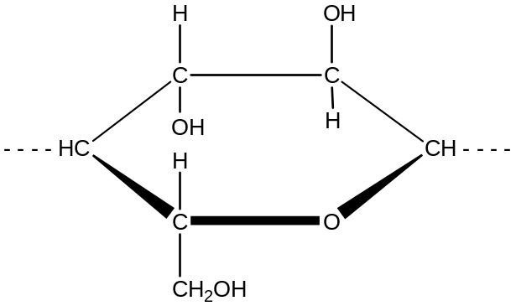

Draw a complete, unbroken border around the part of the structure, which could be
used in the future to make oil-like substitutes 1

MARKS
Question 20 (4 marks)

(a) Explain the chemistry of the dry cell or lead-acid cell in terms of oxidation and
reduction. Support your answer with equation data. 2

…………………………………………………………………………………………

…………………………………………………………………………………………

…………………………………………………………………………………………

…………………………………………………………………………………………

…………………………………………………………………………………………

(b) Describe the flow of electrons in an operating galvanic cell in terms of anode
and cathode. 2

…………………………………………………………………………………………

…………………………………………………………………………………………

…………………………………………………………………………………………

…………………………………………………………………………………………

Student Number …………………………

MARKS
Question 21 (8 marks)

An alcoholic fermentation is performed to quantitatively determine the mass loss during the
course of the reaction. An aqueous glucose mixture is fermented in a vessel resting on the
pan of an electronic balance, which is connected to a data logger, set to record the mass at one
hour intervals.

(a) Draw a labelled diagram of a fermentation vessel suitable for the purpose of this
investigation. 1

(b) Describe storage conditions for the vessel, which would favour the 12-hour fermentation 1

…………………………………………………………………………………………

…………………………………………………………………………………………

(c) The table shows the downloaded file from the data logger.

Elapsed Time (h) | Mass of vessel (g) | Elapsed Time (h) | Mass of vessel (g)
0 | 173.25 | 7 | 170.40
1 | 173.10 | 8 | 170.35
2 | 172.50 | 9 | 170.30
3 | 171.15 | 10 | 170.25
4 | 170.75 | 11 | 170.25
5 | 170.60 | 12 | 170.25
6 | 170.50

Plot the table data on the graph grid. 2

Question 21 continues on page 12
Question 21 (continuation) MARKS


(d) During which one-hour interval was the fermentation most active ? 1

…………………………………………………………………………………………

…………………………………………………………………………………………

(e) Suggest a plausible cause for the plateau on the graph 1

…………………………………………………………………………………………

…………………………………………………………………………………………

…………………………………………………………………………………………

(f) Write the formulae equation for the fermentation process. 1

…………………………………………………………………………………………

(g) Calculate the volume of carbon dioxide gas which escaped (at STP) after 6 hours of
fermentation. 1

……………………………………………………………………………………………………..

……………………………………………………………………………………………………..

……………………………………………………………………………………………………..

End of question 21
Please turn over
Student Number …………………………

MARKS
Question 22 (4 marks)

CFCs and halons in the atmosphere have been identified as the main cause of the upper atmosphere
ozone layer depletion.

(a) Identify one origin of CFCs and one of halons in the atmosphere. 1

…………………………………………………………………………………………

…………………………………………………………………………………………

(b) The graph shows the mean October ozone concentration over the south pole.
Describe the changes observed and explain how this information was obtained. 3
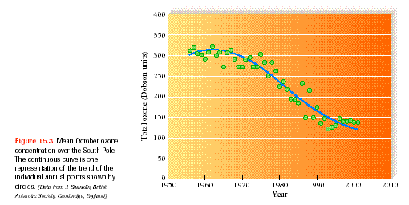
Taken from Chemistry in your Life by C. Baird and W. Gloffke, Freeman Publishing Co, .2003

…………………………………………………………………………………………………

…………………………………………………………………………………………………

…………………………………………………………………………………………………

…………………………………………………………………………………………………

…………………………………………………………………………………………………

…………………………………………………………………………………………………

MARKS
Question 23 (4 marks)

Ammonium sulfate has been used as fertilizer. Analysis of fertilizer is often done
gravimetrically

(a) Write the main formulae equation for the gravimetric determination of sulfate in
fertilizer . 1

…………………………………………………………………………………………

(b) Based on the data given below, calculate the percentage sulfate in a fertilizer
sample. 2

mass of fertilizer: = 0.5010g
mass of sintered glass crucible = 20.2052 g
mass of sintered glass crucible + dried precipitate = 20.7351 g

…………………………………………………………………………………………

…………………………………………………………………………………………

…………………………………………………………………………………………

…………………………………………………………………………………………

…………………………………………………………………………………………

(c) Identify one source of error in this determination. Explain how this error will affect the
percentage sulfate determined 1

…………………………………………………………………………………………

…………………………………………………………………………………………

…………………………………………………………………………………………

…………………………………………………………………………………………

…………………………………………………………………………………………

Test continues next page
Student Number …………………………

MARKS

Question 24 (3 marks)

Describe and assess the effectiveness of methods used to purify and sanitize mass water
supplies. 3

………………………………………………………………………………………………..

…………………………………………………………………………………………………

…………………………………………………………………………………………………

…………………………………………………………………………………………………

…………………………………………………………………………………………………

…………………………………………………………………………………………………

…………………………………………………………………………………………………

…………………………………………………………………………………………………

…………………………………………………………………………………………………

…………………………………………………………………………………………………

Test continues next page, please turn the page over

MARKS
Question 25 (4 marks)

Outline the role of a chemist employed in a named industry or enterprise. Identify the branch
of chemistry undertaken by the chemist and describe a chemical principle that the chemist
uses. 4

……………………………………………………………………………………………………
.
……………………………………………………………………………………………… ……

……………………………………………………………………………………………………

……………………………………………………………………………………………………

……………………………………………………………………………………………………

……………………………………………………………………………………………………

……………………………………………………………………………………………………

……………………………………………………………………………………………………

Question 26 ( 3 marks)

Ammonia can be synthesized from its component gases nitrogen and hydrogen as shown by the
equation:

N₂(g) + 3H₂ (g) 2 NH₃ (g)

Using Le Chateliers principle, explain why the yield of product in this process is reduced at higher temperatures. Identify the synthesis reaction as endothermic or exothermic in your answer. 3

………………………………………………………………………………………………………

………………………………………………………………………………………………………

………………………………………………………………………………………………………

………………………………………………………………………………………………………

………………………………………………………………………………………………………

………………………………………………………………………………………………………

………………………………………………………………………………………………………

………………………………………………………………………………………………………
Student Number …………………………

MARKS
Question 27(6 marks)

Describe the procedure you used to prepare an ester in the school laboratory. Include a
diagram and any relevant equations in your answer . 6

………………………………………………………………………………………………………

………………………………………………………………………………………………………

………………………………………………………………………………………………………

………………………………………………………………………………………………………

………………………………………………………………………………………………………

………………………………………………………………………………………………………

………………………………………………………………………………………………………

………………………………………………………………………………………………………

………………………………………………………………………………………………………

………………………………………………………………………………………………………

………………………………………………………………………………………………………

………………………………………………………………………………………………………

………………………………………………………………………………………………………

………………………………………………………………………………………………………

………………………………………………………………………………………………………

………………………………………………………………………………………………………

Test continues next page, please turn the page over

MARKS
Question 28 (4 marks)

The pH of solutions of acids of the same concentrations were measured :

Acid | Concentration (mol L⁻¹) | pH
citric | 0.1 | 2.1
ethanoic | 0.1 | 2.9
hydrochloric | 0.1 | 1.0

(a) List the acids in order of strength starting from the weakest. 1

………………………………………………………………………………………………………

(b) What is the hydrogen ion concentration of the citric acid solution? 1

………………………………………………………………………………………………………

………………………………………………………………………………………………………

(c) Model the molecular nature and ionization of the acids in the beakers using the
following symbols. 1

acid molecule

acid anion

⊕ hydrogen ion

hydrochloric acid
ethanoic acid

Student Number …………………………

MARKS
Question 29 (3 marks)

Aluminium carbide (Al₄C₃) reacts with excess water to produce methane (CH₄) and aluminium
hydroxide.

(a) Write the formulae equation for the reaction. 1

…………………………………………………………………………………………………………

(b) What mass of aluminium carbide is required to produce 24.79 L of methane at 25⁰C and 100 kPa? 2

…………………………………………………………………………………………………………

…………………………………………………………………………………………………………

…………………………………………………………………………………………………………

…………………………………………………………………………………………………………

Test continues next page, please turn the page over

MARKS

Question 30 ( 4 marks)

A 1.0 molL⁻¹solution of sodium hydrogen carbonate was titrated in separate experiments with
hydrochloric acid and sodium hydroxide. The results are shown in the graph below. The
starting point in both titration was the 0 position indicated on the x-axis.

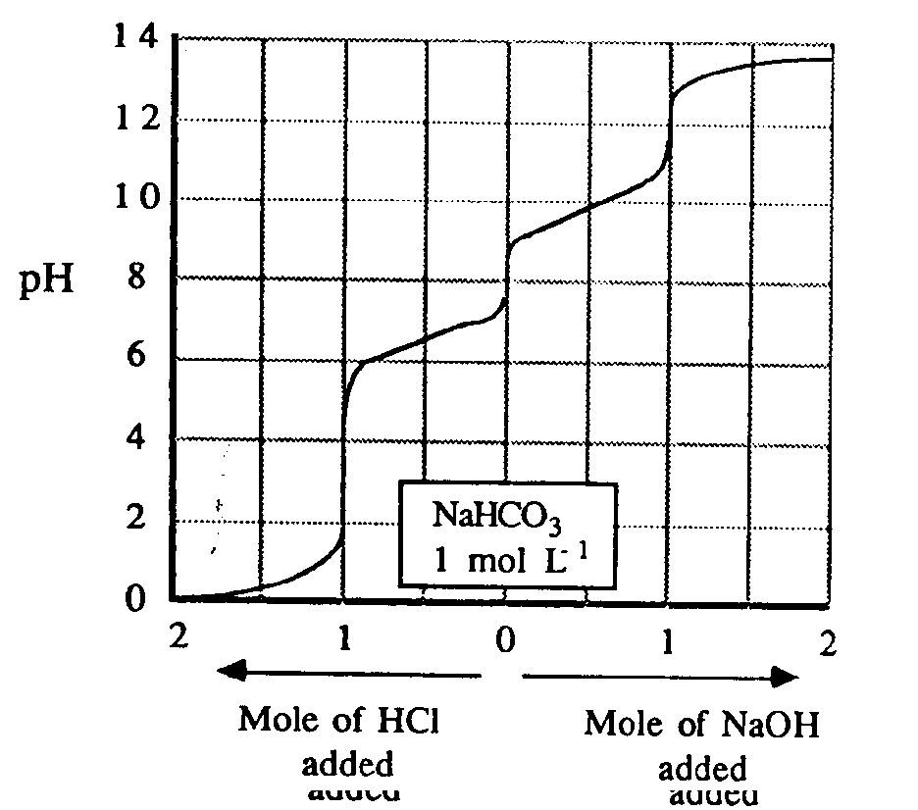

(a) What is an amphiprotic species? Write balanced ionic equations showing how the
hydrogen carbonate ion may react as an amphiprotic species. 3

…………………………………………………………………………………………………………

…………………………………………………………………………………………………………

…………………………………………………………………………………………………………

…………………………………………………………………………………………………………

…………………………………………………………………………………………………………

(b) What is the pH of the 1.0 molL⁻¹ solution of sodium hydrogen carbonate? 1

…………………………………………………………………………………………………………

…………………………………………………………………………………………………………

Section II

25 marks

Attempt Question 31
Allow about 45 minutes for this section.

Answer the question in a writing booklet provided
Show all relevant working in questions involving calculations

Question 31 MARKS

(a) Write anode and cathode reactions that occur during the electrolysis of copper (II) chloride
solution and sodium sulfate solution using copper metal electrodes and the minimum possible
voltage. 4

Reaction at the anode and cathode during electrolysis of two solutions

Electrode | Copper(II)chloride | Sodium sulfate
Anode

Cathode

(b) Cathodic protection is one way of protecting iron and iron-based materials from
corrosion.

Identify two applications or techniques for corrosion prevention utilising cathodic
protection. Use relevant ionic equations to support your answer. 4

(c) Discuss one technique other than cathodic protection which is used to protect a ship's
metal hull from corrosion 2

(d) Discuss the nature of the corrosion that can occur if a lead gutter were nailed to a house
using tin nails. 2

(e) ( i.)Use the information given in the following diagrams to predict the effect of low
temperatures at great depths on the rate of corrosion of a metal. Justify your prediction 4
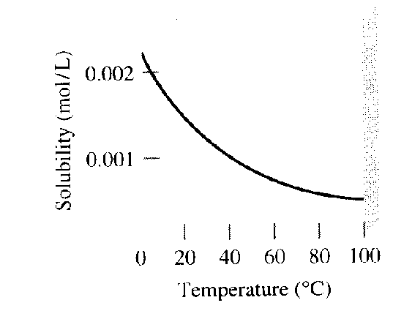Diagram1. Graph of solubility of O₂ gas as a function of
temperature.
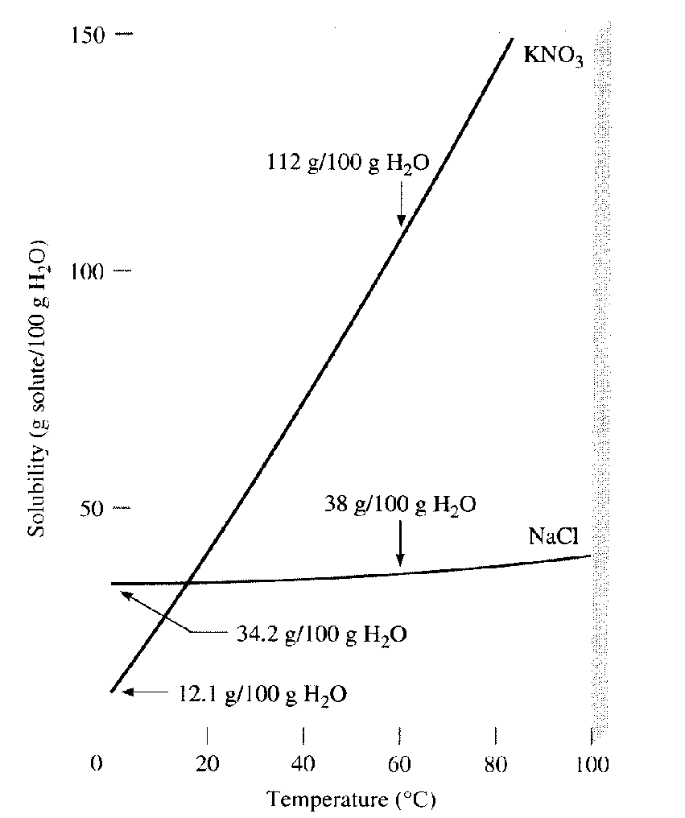

Diagram 2. Graph of the solubility of NaCl and KNO₃
against temperature.
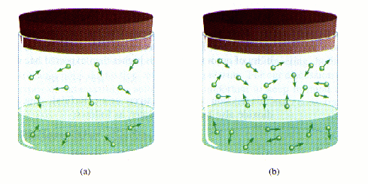:
Diagram 3. Effect of pressure on the solubility of a gas.
Diagram taken from Chemistry by Chang, 1996.

(e) (ii) Other than the information given in these diagrams, identify factors or processes that control
the concentration of oxygen and carbon dioxide in the ocean waters 2

(f) What is the best way to store partly used steel wool in the kitchen? The options available are :

- keeping it immersed in plain tap water
- keeping it immersed in soapy water (a basic solution)
- keeping it immersed in a carbonated drink

Plan an investigation to find out the option which will result to least rusting. 7
Your plan must include the following:
- your hypothesis and a justification for this
- a brief outline of the procedure or the strategy of the determination
- an identification of the dependent, independent and controlled variables in the
in the experiment.
- recommendation on improving the reliability of the experiment

You should organize your answers in such a way as to explicitly address
the above 4 points
END OF TEST

